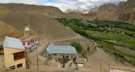 |  |   SCHOLARSCHIP PROGRAM
 |  | Spring Dales Public School
 |  | Mulbekh; Ladakh, J&K, India
Date of issue |  | 23rd April, 2013
CHILD
Name |  | 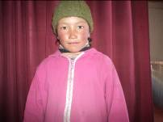  Tsewang Yangdol
Date of birth |  | 28/02/2007
Gender |  | Girl
Class in which to admit |  | 2nd class
Currently present school |  | 2nd class SDPS
Favorite subject |  | Social, Hindi
Hobbies |  | Dancing, Drawing
Dream to become |  | Teacher
Few words about |  | Tsewang Yangdol is talented student of 2nd class. She is active in class and she loves to do various activities, drawing and dancing. She likes the most Social and Hindi. She is very interested in dancing and she loves performances of SDPS for various kinds of functions. Yangdol feels to be very happy in SDPS and she is having many of good friends there.
PARENTS |  | Tsewang Yangdol with her mother
Father | Name | 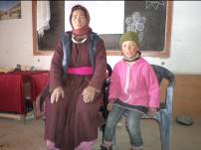  Tsering Wangldan
 | Job | No/Farmer
 | Education | 5th class
Mother | Name | Sonam Angmo
 | Job | No/Housewife
 | Education | 11th class
HOUSEHOLD
Few words about |  | Tsewang Yangdol lives with her brothers and parents in an old house in the village Whaka, 2km far away from the SDPS. She walks 1h each day to addend SDPS with her friends. Property of family and economic condition is very poor, but is full of good will and love. Parents are trying very hardly to safe money each year to provide quality education at least for their daughter.
Number of adults |  | 2
Number of children |  | 3
Number of people in household in total |  | 5
Age and gender of children |  | 12 years (boy) | 11 years (boy) | 6 year (girl) 2nd SDPS
Education of children |  | 8th class Gvt. | 6th Gvt school

