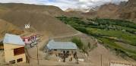 |  |   SCHOLARSCHIP PROGRAM
 |  | Spring Dales Public School
 |  | Mulbekh; Ladakh, J&K, India
Date of issue |  | 20thFebruary , 2013
CHILD |  | 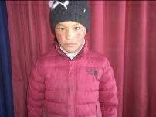
Name |  | Sonam Tsomo
Date of birth |  | 26/12/2005
Gender |  | Girl
Class in which to admit |  | 2nd class
Currently present school |  | 2nd class SDPS
Favorite subject |  | Science, English
Hobbies |  | Kho-kho, Dance
Dream to become |  | Teacher
Few words about |  | Sonam Tsomo is one of the best students in 2nd class. With her lovely smile, she is always filling all tasks as a first one. She is very interested in learning and she loves environment in SDPS. One day she would like to become teacher and be helping children from poor families to get good level of education. She is very good singer and dancer too and she never missed any opportunity to be part of any performance of SDPS.
PARENTS |  | 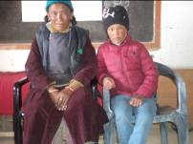
Father | Name | Stanzin Angchok
 | Job | Temporary govt class IV employee
 | Education | 8th class
Mother | Name | Yangshan Dolma
 | Note | House wife/farmer
 | Education | Un-educated
HOUSEHOLD
Few words about |  | Sonam Tsomo lives in village 1km far away from SDPS with her family. She walks every day ½ h in hilly terrain to attend the school. Unfortunately, the economic condition of the family is very very poor. As Sonam Tsomo is very talented, responsible and motivated student, their parents are trying very hard to safe money needed for paying of quality education for her.
Number of adults |  | 2
Number of children |  | 5
Number of people in household in total |  | 7
Age and gender of children |  | 19 years (girl) | 18 years (boy) | 16 years (boy) | 11 years (girl) | 7 years (girl)
Education of children |  | 10th govt school | 8th class Gvt. | 8th govt class | 8th Gvt school | 2rd class SDPS

