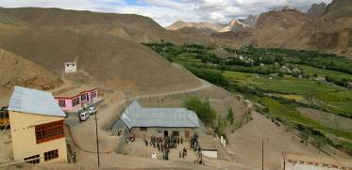 |  | 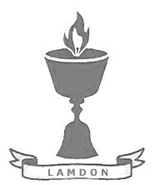  SCHOLARSCHIP PROGRAM
 |  | Spring Dales Public School
 |  | Mulbekh; Ladakh, J&K, India
Date of issue |  | 10th April, 2012
CHILD |  | 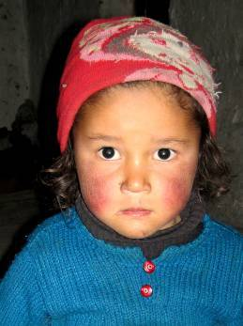
Name |  | THINLES ANGMO
Date of birth |  | 02/04/2009
Gender |  | Girl
Class in which to admit |  | LKG
Currently present school |  | Primary government school
Favorite subject |  | English
Hobbies |  | Singing, Drawing
Few words about |  | Thinles Angmo is three-years old girl, who already attends local Government Primary School. The most, she likes writing and reading of English letters and naming of pictures. She seems to become very eager student in future. She likes singing and drawing a lot too.
PARENTS |  | Thinles Angmo with her mother and grandmother
Father | Name | 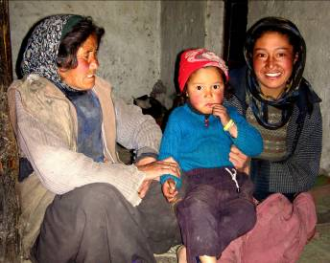  Thinles Norboo
 | Job | No/Farmer
 | Education | 10th class
Mother | Name | Tundup Dolkar
 | Job | No/Housewife
 | Education | 10th class
HOUSEHOLD
Few words about |  | Thinles Angmo lives in an old house together with her parents and grandparents. Even though the economic situation of family is very poor, the sensation there is very cheerful and peaceful. Angmo’s mother cares about her daughter too much and she spends a lot of time with her playing and teaching. Parents wish too much to unsure great level of education for their talented and smart daughter and support her in all ways they are able to manage.
Number of adults |  | 4
Number of children |  | 1
Number of people in household in total |  | 5
Age and gender of children |  | 3 years (girl)
Education of children |  | Primary Gvt.

