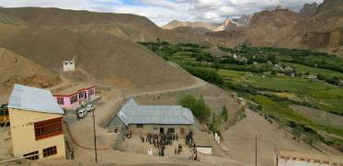 |  |   SCHOLARSCHIP PROGRAM
 |  | Spring Dales Public School
 |  | Mulbekh; Ladakh, J&K, India
Date of issue |  | 8th April, 2012
CHILD |  | 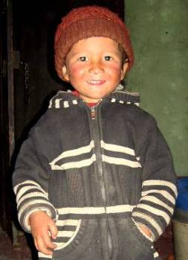
Name |  | LOBZANG GYALSON
Date of birth |  | 31/07/2008
Gender |  | Boy
Class in which to admit |  | LKG
Currently present school |  | ------------------
Favorite subject |  | ------------------
Hobbies |  | Drawing, Books
Few words about |  | Lobzang Gyalson is very clever and energetic three-years old boy. He doesn’t attend a school yet, but his mother and father spend a lot of time with him by playing and learning. He can already read and write letters in Enslish and he is very eager for knowledge. Studying in SDPS will be the best way for his full development of his personality and talent.
PARENTS |  | Lobzang Gyalson with his mother Lobzang Gyalson with his book
Father | Name | 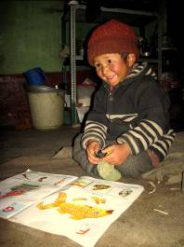  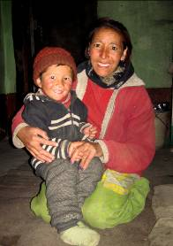  Tsewang Dorjay
 | Job | No/Farmer
 | Education | 9th class
Mother | Name | Tsering Dolma
 | Job | No/Housewife
 | Education | 12th class
HOUSEHOLD
Few words about |  | Lobzang Gyalson lives with his parents in very old and small house in Mulbekh. Family property is just a small field, on which father and mother are working during all the season. Standard of living in household is very low, but is full of good will. Mother is taking care about small Lobzang a lot, she loves playing with him and she teaches him basics of English alphabet and basic words. Family is living in very peaceful and cheerful way and parents dream to give their son the best education and opportunities for his life.
Number of adults |  | 2
Number of children |  | 1
Number of people in household in total |  | 3
Age and gender of children |  | 3 years (boy)
Education of children |  | ----------------

