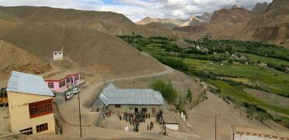 |  |   SCHOLARSCHIP PROGRAM
 |  | Spring Dales Public School
 |  | Mulbekh; Ladakh, J&K, India
Date of issue |  | 11th April, 2012
CHILD |  | 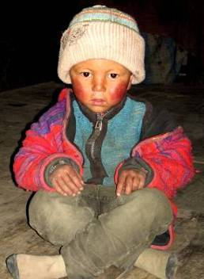
Name |  | STANZIN SHARAB
Date of birth |  | 18/04/2007
Gender |  | Boy
Class in which to admit |  | UKG class
Currently present school |  | UKG class government school
Favorite subject |  | Math, English
Hobbies |  | Drawing, Singing
Few words about |  | Stanzin Sharab is five-years old boy, who already attends UKG class in local Government School. He is very hardworking and responsible student and he likes Math and English the best. He loves drawing and singing too and he is eager to become a part of any SDPS performance.
PARENTS |  | Stanzin Sharab with his sisters Stanzin Sharab with his family
Father | Name | 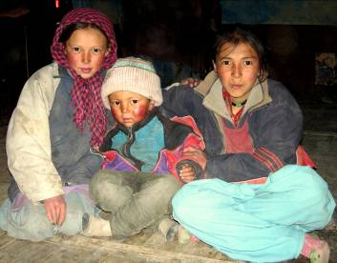  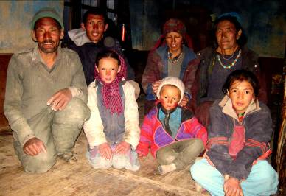  Tsewang Dorjay
 | Job | No/Farmer
 | Education | 10th class
Mother | Name | Tsering Dolkar
 | Job | No/Housewife
 | Education | No
HOUSEHOLD
Few words about |  | Stanzin lives in an old house in the village 12km far away of SDPS. For that reason, the hostel of SDPS is required and needed. His older sister Stanzin Mutop is student of 7th class in SDPS and she walks to school every day. Stanzin’s parents could observe how different the level of education in government school and SDPS is. Unfortunately, they can’t get enough of finances to provide education in SDPS for all their kids. As Stanzin Sharab is very talented and responsible in his learning, they wish so much to unsure great school environment and opportunities, as SDPS offers.
Number of adults |  | 4
Number of children |  | 4
Number of people in household in total |  | 8
Age and gender of children |  | 14 years (girl) | 11 years (girl) | 7 years (girl)
Education of children |  | 7th class SDPS | 6th class Gvt. | Nun

