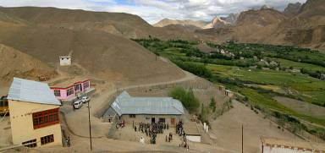 |  |   SCHOLARSCHIP PROGRAM
 |  | Spring Dales Public School
 |  | Mulbekh; Ladakh, J&K, India
Date of issue |  | 7th April, 2012
CHILD
Name |  | 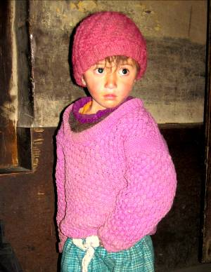  TUNDUP DOLKAR
Date of birth |  | 16/10/2008
Gender |  | Girl
Class in which to admit |  | LKG class
Currently present school |  | LKG class government school
Favorite subject |  | English
Hobbies |  | Singing, Dancing
Few words about |  | Tundup Dolkar is very cute, four years old girl, who already attends LKG class in local Government School. She likes learning and her favorite subject is English, writing and reading letters and naming of pictures. She is quite shy, but as she loves dancing and singing, she can gain a lot of confidence in possible attending of SDPS functions, which she loves to watch in any celebration or festival.
PARENTS |  | Tundup Dolkar with her sisters and brother Tundup Dolkar with her family
Father | Name | 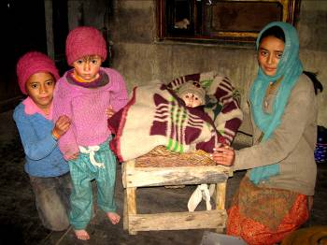  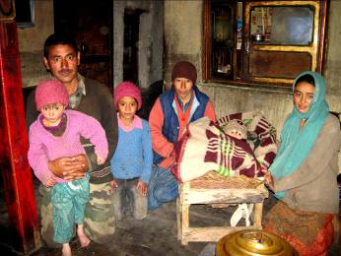  Mingur Dorjay
 | Job | Labour in Army
 | Education | 8th class
Mother | Name | Tsering Dolma
 | Job | Housewife
 | Education | 12th class
HOUSEHOLD
Few words about |  | Tundup Dolkar lives in very old house with her 3 elder sisters, one younger brother and parents. Dolkar’s father works as a labour in army, but the salary is very low there, even to provide food for his family. The sensation in the household is very cheerful and peaceful. Parents behave their kids in love and in the way of Buddhist philosophy. All their kids are very talented and hardworking students. Unfortunately, level of government education can’t be good enough to unsure better future for kids.
Number of adults |  | 2
Number of children |  | 5
Number of people in household in total |  | 7
Age and gender of children |  | 17 years (girl) | 14 years (girl) | 9 years (girl) | 4 years (girl) | 1 year (boy)
Education of children |  | 11th class | 7th class | 4th class | UKG class | ----------------

