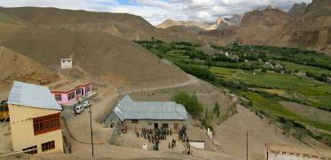 |  |   SCHOLARSCHIP PROGRAM
 |  | Spring Dales Public School
 |  | Mulbekh; Ladakh, J&K, India
Date of issue |  | 18th April, 2012
CHILD |  | 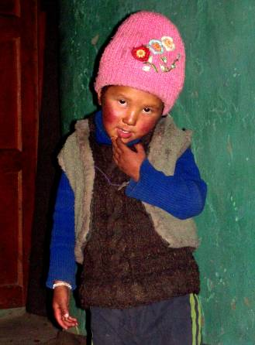
Name |  | PADMA DOLKAR
Date of birth |  | 07/05/2008
Gender |  | Girl
Class in which to admit |  | LKG class
Currently present school |  | Primary government school
Favorite subject |  | English
Hobbies |  | Dancing, Singing
Few words about |  | Padma Dolkar is four year old girl, who already attends Primary Goverment School. She likes English the most and she loves to dance and sing a lot. She is quite shy, but very clever girl, who dreams about joining to SDPS students and enjoy studies and activities with them.
PARENTS |  | Padma Dolkar with her sister Padma Dolkar with her family
Father | Name | 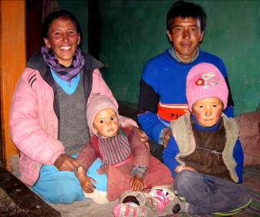  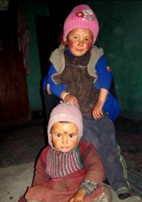  Stanzin Khunzang
 | Job | No/Farmer
 | Education | 8th class
Mother | Name | Rinchen Dolma
 | Job | No/Housewife
 | Education | 10th class
HOUSEHOLD
Few words about |  | Padma Dolkar lives in an old house together with her younger sister and parents. Parents are farmers and their propriety is just few of small fields and the old house. Both of them can’ t get better education then in local Government School, but they dream about giving this chance to their two lovely daughters and ensure like that for them better future. The sensation in the family is full of love, smiles and believes.
Number of adults |  | 2
Number of children |  | 2
Number of people in household in total |  | 4
Age and gender of children |  | 4 years (girl) | 1 year (girl)
Education of children |  | Primary school Gvt. | ------------------

