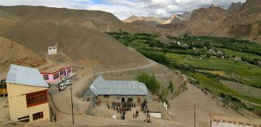 |  | 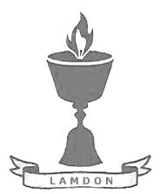  SCHOLARSCHIP PROGRAM
 |  | Spring Dales Public School
 |  | Mulbekh; Ladakh, J&K, India
Date of issue |  | 12th April, 2012
CHILD |  | 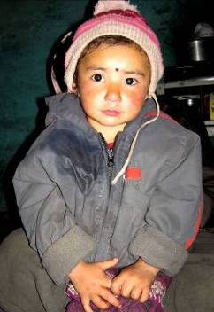
Name |  | JIGMETH YANGCHAN
Date of birth |  | 21/06/2009
Gender |  | Girl
Class in which to admit |  | LKG class
Currently present school |  | -----------------
Favorite subject |  | -----------------
Hobbies |  | Drawing, Singing
Few words about |  | Jigmeth Yangchan is three-years-old girl from Mulbekh. Maybe according to her unfortunate fate, she is quite shy and introvert personality, but studying in SDPS will be the best for gaining of her life confidence. She loves drawing or singing with her grandmother and six-years-old aunt Nilza.
PARENTS |  | Jigmeth Yangchan with uncle and aunt Jigmeth Yangchan with her family
Father | Name | 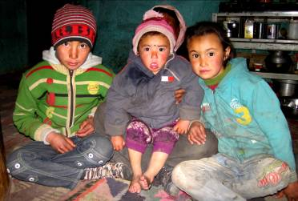  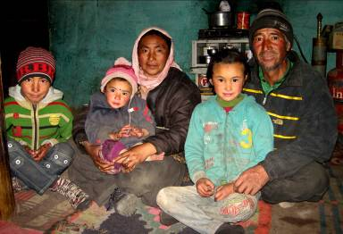  Thamchas Gurmath
 | Note | Died one year ago
 | Education | ------------
Mother | Name | Tsewang Dolkar
 | Note | Living with new family
 | Education | 9th class
HOUSEHOLD
Few words about |  | Jighmeth lives with her grandparents and their four kids in an old house in Mulbekh. Jighmeth’s father died one year ago and her mother got married again and she is living with her new family in another village. Jigmeth’s grandmother tries her best to make Jigmeth’s life happier and she treats her as her own daughter. She wishes very much to unsure for Jigmeth better future and change her fate, which haven’t been so fortunate till now. Beside providing a great family environment full of joy and love, she wish to give Jigmeth opportunity to study and develop herself in a great school environment full of smiling teachers and open-minded and kind-hearted kids.
Number of adults |  | 2 (grandparents)
Number of children |  | 5 (uncle and aunts of Jigmeth Yangchan)
Number of people in household in total |  | 7
Age and gender of children |  | 24 years (girl) | 18 years (girl) | 13 years (boy) | 6 years (girl) | 3 years (girl)
Education of children |  | 9th class Gvt. | 10th class Gvt. | 3rd class Gvt. | 2nd class Gvt. | ----------------

