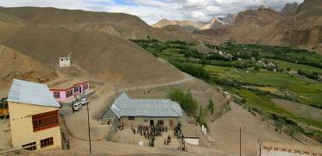 |  | 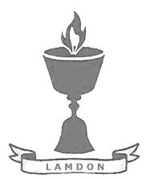  SCHOLARSCHIP PROGRAM
 |  | Spring Dales Public School
 |  | Mulbekh; Ladakh, J&K, India
Date of issue |  | 28th May, 2012
CHILD |  | 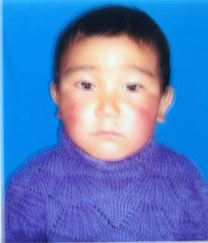
Name |  | THINLES MINGYUR
Date of birth |  | 24/03/2008
Gender |  | Boy
Class in which to admit |  | LKG class
Currently present school |  | LKG Government school
Favorite subject |  | English, Bhoti
Hobbies |  | Drawing, Singing
Few words about |  | Thinles Mingyur is four-year old boy, who already attends LKG class in government school. He is very talented and cheerful boy and he seems to become a great and hardworking student. He loves drawing and singing or playing any kind of sports.
PARENTS
Father | Name | Tsewang Targyas
 | Job | Labour
 | Education | 5th class
Mother | Name | Tsering Dolkar
 | Note | No/Housewife
 | Education | 5th class
HOUSEHOLD
Few words about |  | Thinles lives with his mother in an old house. His olders brothers are studying in other places – one is studying in Leh and the other became a monk. Family economic situation is very bad. Even father works as a labor in Leh, where he takes care about the oldest son, his salary is very low and hardly covers expenses of the family during the year. Mother is looking about an old house and few of fields, and about Thinles grandparents. Parents dream to unsure better level of education and great opportunities for living for their children then they got during their studies in government schools.
Number of adults |  | 2
Number of children |  | 1
Number of people in household in total |  | 3
Age and gender of children |  | 10 years (boy) | 8 years (boy) | 4 years (boy)
Education of children |  | 3rd class private Leh | monk | LKG Gvt.

