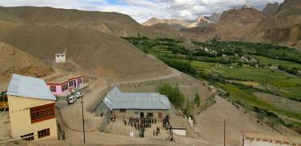 |  |   SCHOLARSCHIP PROGRAM
 |  | Spring Dales Public School
 |  | Mulbekh; Ladakh, J&K, India
Date of issue |  | 18th April, 2012
CHILD |  | 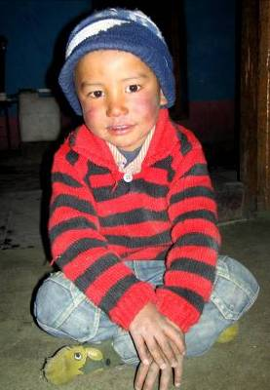
Name |  | STANZIN TASHI
Date of birth |  | 31/07/2008
Gender |  | Boy
Class in which to admit |  | LKG class
Currently present school |  | -----------------
Favorite subject |  | -----------------
Hobbies |  | Drawing, Singing
Dream to become |  | Police inspector
Few words about |  | Stanzin Tashi is very energetic and cheerful boy. In his four years, he is enjoying drawing and singing or playing cricket and running with his friends. He seems to become very responsible and keen student, who will always fill all tasks and homework to the point. One day he would like to become a police inspector to protect all good people of the village.
PARENTS |  | Stanzin Tashi with his family Stanzin Tashi with his best friend
Father | Name | 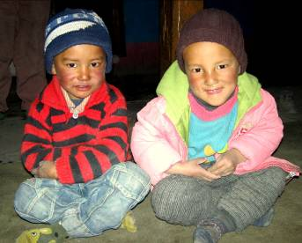  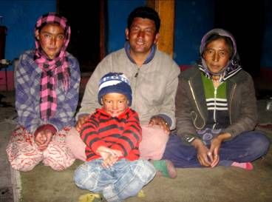  Tashi Rabgyas
 | Job | No/Farmer
 | Education | 8th class
Mother | Name | Tsering Dolma
 | Job | No/Housewife
 | Education | 10th class
HOUSEHOLD
Few words about |  | Tashi lives in an old house together with his parents and aunt. Parents’ property is just this old house and few of fields on which they are working during a year. They wish to unsure better opportunities for living for their son’s life and his village too, and they see the quality education as the best way, how to do so. The sensation in the family is full of love, good will and smiles.
Number of adults |  | 3
Number of children |  | 1
Number of people in household in total |  | 4
Age and gender of children |  | 3 years (boy)
Education of children |  | -----------------

