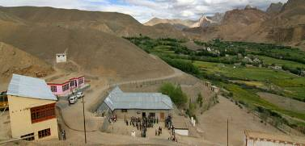 |  |   SCHOLARSCHIP PROGRAM
 |  | Spring Dales Public School
 |  | Mulbekh; Ladakh, J&K, India
Date of issue |  | 7th April, 2012
CHILD |  | 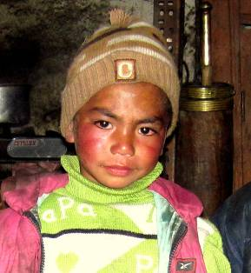
Name |  | TSEWANG TONRAB
Date of birth |  | 24/05/2008
Gender |  | Boy
Class in which to admit |  | LKG class
Currently present school |  | LKG class government school
Hobbies |  | Dancing, Sport
Few words about |  | Tsewang Tonrab is four years old boy, who lives in Wakha. Currently, he attends LKG class in Government school. He likes learning and he is enjoying every kind of sport. He loves dancing and singing, and he dreams about performing on any SDPS function.
PARENTS |  | Tsewang Tonrab with his parents
Father | Name | 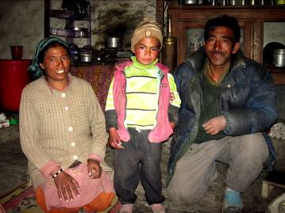  Eshey Dorjay
 | Job | Labor
 | Education | No
Mother | Name | Punchok Angmo
 | Job | Housewife
 | Education | No
HOUSEHOLD
Few words about |  | Tsewang Tonrab lives in an old house with his parents and with his older brother and sister. Even his father works as a labour, his salary is too low to pay his kids high quality education in a private school. Tsewang Tonrab’s parents wish to at least one of their kids can gain better opportunities for his life by getting high level of education. They behave their children in the way of Buddhist philosophy, respect for the family and nature.
Number of adults |  | 2
Number of children |  | 3
Number of people in household in total |  | 5
Age and gender of children |  | 11 years (boy) | 9 years (girl) | 4 years (boy)
Education of children |  | 5th class GVT | 2nd class GVT | LKG class GVT
Family property |  | Field

