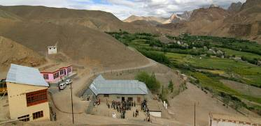 |  |   SCHOLARSCHIP PROGRAM
 |  | Spring Dales Public School
 |  | Mulbekh; Ladakh, J&K, India
Date of issue |  | 8th April, 2012
CHILD |  | 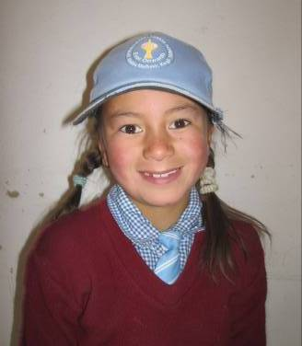
Name |  | STANZIN ANGMO
Date of birth |  | 15/09/2005
Gender |  | Girl
Class in which to admit |  | 2nd
Currently present school |  | SDPS
Favorite subject |  | English, Bhoti
Hobbies |  | Singing, Dance
Dream to become |  | Teacher
Few words about |  | Stanzin Angmo is one of the best students of 2nd class in SDPS. She is very motivated, active and responsible student, always filling the tasks as a first and interested to get new ones. She feels to be very happy in SDPS with all teachers and her schoolmates. She loves functions of SDPS and she is always enthusiast to be part of any performance.
PARENTS |  | Stanzin Angmo with her schoolmates
Father | Name | 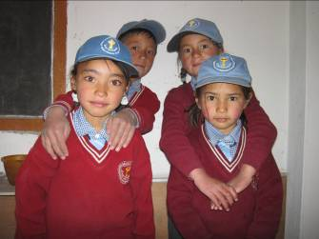  Sonam Stopdan
 | Job | No/Farmer
 | Education | 8th class
Mother | Name | Tsewang Dolma
 | Job | No/Housewife
 | Education | No
HOUSEHOLD
Few words about |  | Family property is just a small field and old house in which is living six members of the family. Brothers of Stanzin Angmo are attending government school, but the level of education there is very low. Parents would like to provide better level of education at least for their daughter, which is very talented and hardworking student. She already passed UKG and 1st class in SDPS and she is one of the best students of the class. She is very happy in the school and she already got plenty of knowledge there. Unfortunately for her parents will be not possible to effort this private education for further years.
Number of adults |  | 3
Number of children |  | 3
Number of people in household in total |  | 6
Age and gender of children |  | 15 years (boy) | 13 years (boy) | 6 years (girl)
Education of children |  | 8th class GVT | 7th class GVT | 2nd class SDPS

