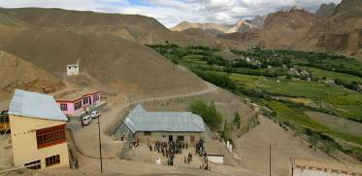 |  | 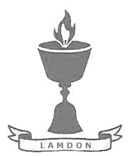  SCHOLARSCHIP PROGRAM
 |  | Spring Dales Public School
 |  | Mulbekh; Ladakh, J&K, India
Date of issue |  | 10th April, 2012
CHILD |  | 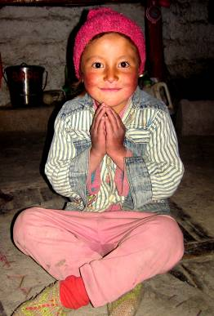
Name |  | DAWA DOLMA
Date of birth |  | 31/05/2006
Gender |  | Girl
Class in which to admit |  | UKG
Currently present school |  | 1st government school
Favorite subject |  | Math, English
Hobbies |  | Singing, Dancing
Dream to become |  | Teacher
Few words about |  | Dawa Dolma is very funny, cheerful and energetic girl. She already attends government school and she loves learning just way too much. She dreams to become a part of SDPS and gain opportunity to reach quality education and learn more. She is very responsible and accurate student, who always fills her homework and tasks. One day, she would like to become a teacher and lead her students to love for learning.
PARENTS |  | Dawa Dolma with her mother
Father | Name | 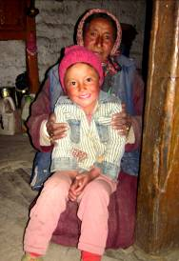  Sonam Dorjay
 | Job | No/Farmer
 | Education | No
Mother | Name | Yangchan Dolma
 | Job | No/Housewife
 | Education | No
HOUSEHOLD
Few words about |  | Dawa Dolma comes from a large family. Her parents are farmers and their propriety are just few of fields and an old house. Against their life struggle with funds, they support their children in studies and lead them to live in the way of Buddhist philosophy. Unfortunately, they have no enough finances to provide quality education in private school for all their kids. They will be infinitely grateful for any help in fulfilling of their dream and ensure Dawa Dolma great level of education in SDPS.
Number of adults |  | 2
Number of children |  | 9
Number of people in household in total |  | 11
Age and gender of children |  | 24 years (girl) | 22 years (girl) | 20 years (girl) | 16 year (girl) | 14 year (girl)
Education of children |  | Bsc. | 12th class Gvt. | 10th class Gvt. | 10th class Gvt. | 5th class Gvt.
Age and gender of children |  | 12 years (boy) | 10 years (girl) | 8 years (girl) | 6 year (girl)
Education of children |  | 4th class Gvt. | 2nd class Gvt. | 2nd class Gvt. | 1st class Gvt.

