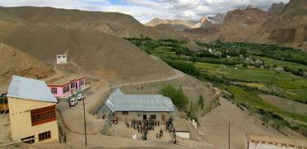 |  |   SCHOLARSCHIP PROGRAM
 |  | Spring Dales Public School
 |  | Mulbekh; Ladakh, J&K, India
Date of issue |  | 17th April, 2012
CHILD |  | 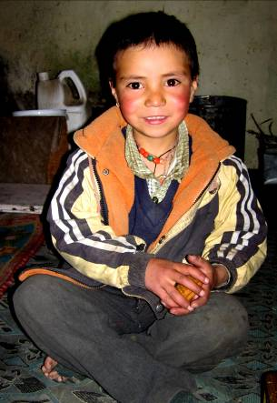
Name |  | JIGMETH TANTAR
Date of birth |  | 11/10/2005
Gender |  | Boy
Class in which to admit |  | 1st class
Currently present school |  | 2nd government school
Favorite subject |  | English, Hindi
Hobbies |  | Drawing, Cricket
Dream to become |  | Driver
Few words about |  | Jigmeth Tantar is very cheerful and energetic boy, who already attend government school in Shargol. He walks every day almost 2h to attend the school. His great wish is to become a part of SDPS and have opportunity to enlarge his knowledge and skills and to attend SDPS functions.
PARENTS |  | Jigmeth Tantar with his family
Father | Name | 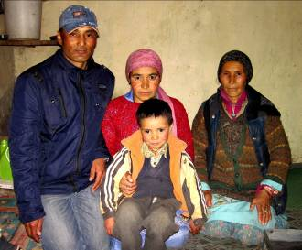  Konchok Raftan
 | Job | Season night guider SDPS/Farmer
 | Education | 10th class
Mother | Name | Yangchan Dolma
 | Job | No/Housewife
 | Education | 7th class
HOUSEHOLD
Few words about |  | Jigmeth lives in an old house hidden in the hills almost 1h of walk from the main road. The family economic conditions are very poor, so SDPS offered a job of season night guider to Jigmeth’s father. The sensation in the family is full of joy and good will and all members are sharing their hard daily life with a smile on their faces. Parents will be infinitely happy if their son can reach a such quality education as is offered in SDPS.  Walk from Jigmeth’s house to SDPS is 10km and takes 3h, so hostel is required and needed.
Number of adults |  | 4
Number of children |  | 2
Number of people in household in total |  | 6
Age and gender of children |  | 6 years (boy) | 4 years (girl)
Education of children |  | 2nd class Gvt. | Nun

