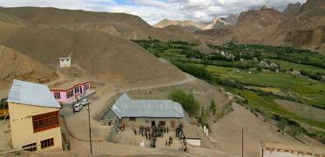 |  | 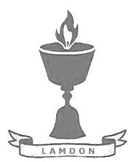  SCHOLARSCHIP PROGRAM
 |  | Spring Dales Public School
 |  | Mulbekh; Ladakh, J&K, India
Date of issue |  | 10th April, 2012
CHILD |  | 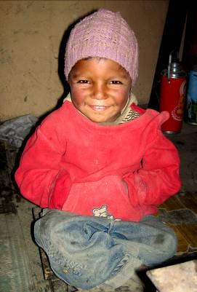
Name |  | STANZIN NORBOO
Date of birth |  | 22/07/2006
Gender |  | Boy
Class in which to admit |  | LKG
Currently present school |  | 1st government school
Favorite subject |  | Bhoti, English
Hobbies |  | Singing, Drawing
Dream to become |  | Police inspector
Few words about |  | Stanzin Norboo is a gladsome and very clever boy. He is very hardworking and responsible student. He loves singing and he is dreaming to be part of numerous SDPS functions. One day, he would like to become a police inspector to be a protector of good people.
PARENTS |  | Stanzin Norboo with brothers Stanzin Norboo with his family
Father | Name | 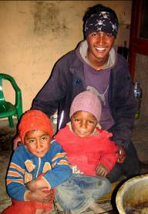  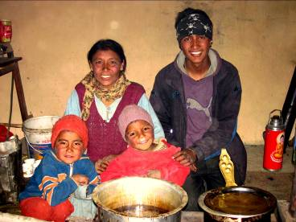  Tashi Namgyal
 | Job | No/Farmer
 | Education | 5th class
Mother | Name | Lobzang Tsering
 | Job | No/Housewife
 | Education | No
HOUSEHOLD
Few words about |  | Norboo lives in an old house in Mulbekh. Economic condition of family is very poor. Parents are working on few of fields to grow vegetable and crop for needs of the family. Anyway, the sensation in the family is very cheerful and friendly. Brothers are supporting and helping each other, as well as they do to their parents. Parents will be infinitely happy if at least one of their child could reach a quality education in private school.  Norboo’s brother Stanzin Jigmeth is also very interested in attending to SDPS. He and his family will be very grateful for finding any sponsorship for him as well.
Number of adults |  | 2
Number of children |  | 4
Number of people in household in total |  | 6
Age and gender of children |  | 18 years (boy) | 10 years (boy) | 6 years (boy) | 4 year (boy)
Education of children |  | 10th class Gvt. | monk | 1st class Gvt. | LKG class Gvt

