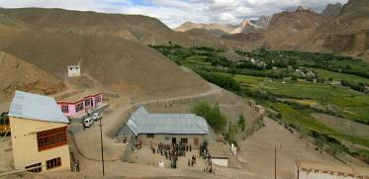 |  | 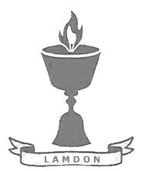  SCHOLARSCHIP PROGRAM
 |  | Spring Dales Public School
 |  | Mulbekh; Ladakh, J&K, India
Date of issue |  | 12th April, 2012
CHILD |  | 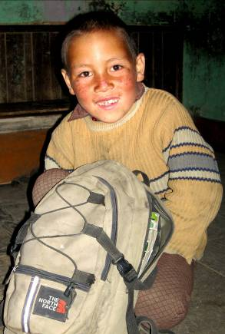
Name |  | THINLES DORJAY
Date of birth |  | 02/07/2005
Gender |  | Boy
Class in which to admit |  | UKG class
Currently present school |  | 1st class government school
Favorite subject |  | English, Math
Hobbies |  | Drawing, Cricket
Dream to become |  | Doctor
Few words about |  | Thinles Dorjay is very energic and joyful boy, who is very hardworking and responsible in his studies. He dreams about attending the SDPS along with his brother Jungnas, who is reading 3rd class. Thinles is dreaming to be part of such quality education process, have fun in sports or be part of any functions of SDPS. One day, he would like to become a doctor to help sick people in their hard times.
PARENTS |  | Thinles Dorjay with his brothers Thinles Dorjay with his family
Father | Name | 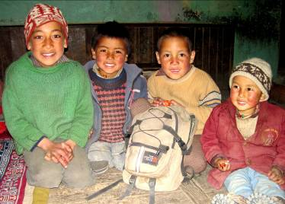  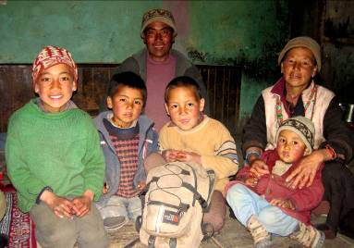  Smonlla Tundup
 | Job | No/Farmer
 | Education | 5th class
Mother | Name | Tsering Dolkar
 | Job | No/Housewife
 | Education | No
HOUSEHOLD
Few words about |  | Thinleses house is 9km far away of SDPS, which is like 1.5h of walking one way. Thinles will be absolutely happy to join his brother Jungnas in their every day walk to SDPS for getting a great education and fun with SDPS students. Sensation in the family is really lovely, full of joy and smile. Parents are very proud of their talented children and behave them the best in the way of Buddhist philosophy.
Number of adults |  | 3
Number of children |  | 7
Number of people in household in total |  | 10
Age and gender of children |  | 20 years (girl) | 18 years (boy) | 17 years (boy) | 8 years (boy) | 5 years (boy)
Education of children |  | Bed. 1st year | 11th class Gvt. | 12th class Gvt. | 3rd class SDPS | UKG class Gvt.
Age and gender of children |  | 4 years (boy) | 2 years (boy)
Education of children |  | UKG class Gvt. | -----------------

