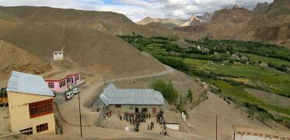 |  |   SCHOLARSCHIP PROGRAM
 |  | Spring Dales Public School
 |  | Mulbekh; Ladakh, J&K, India
Date of issue |  | 12th April, 2012
CHILD |  | 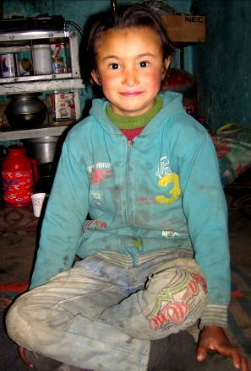
Name |  | NILZA ANGMO
Date of birth |  | 04/09/2003
Gender |  | Girl
Class in which to admit |  | UKG class
Currently present school |  | 2nd class government school
Favorite subject |  | English, Math
Hobbies |  | Drawing, Kho-kho
Dream to become |  | Police inspector
Few words about |  | Nilza Angmo is very clever, hardworking and responsible girl from Mulbekh. She loves learning and she is very consistent in her studies. She loves sport and she is dreaming to attend any sport games and competitions which are taking held in SDPS. One day she would like to become a police inspector to protect all good people of the village.
PARENTS |  | Nilza Angmo with her brother and niece Nilza Angmo with her family  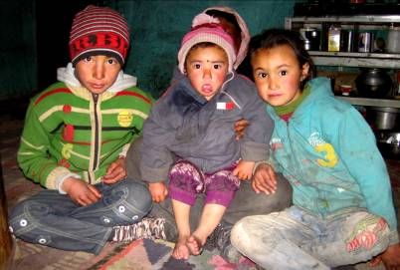  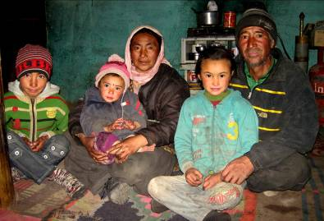
Father | Name | Tundup Tsering
 | Job | No/Farmer
 | Education | 8th class
Mother | Name | Punchok Dolma
 | Job | No/Housewife
 | Education | 4th class
HOUSEHOLD
Few words about |  | Nilza came from a large family. She has got four sisters and one brother. After her sister got divorced, Nilza’s parents are taking care about Nilza’s niece as well. The economic condition in the family is very poor. They are living in very old house, sharing just few of rooms. Parents are working in few of their fields to plant vegetable and crop.
Number of adults |  | 2
Number of children |  | 6 (1 niece of Nilza Angmo)
Number of people in household in total |  | 7
Age and gender of children |  | 26 years (girl) | 24 years (girl) | 18 years (girl) | 13 years (boy) | 6 years (girl)
Education of children |  | 9th class Gvt. | 9th class Gvt. | 10th class Gvt. | 3rd class Gvt. | 2nd class Gvt.
Age and gender of children |  | 2 years (girl)
Education of children |  | ----------------

