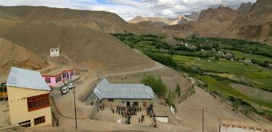 |  | 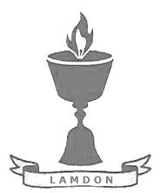  SCHOLARSCHIP PROGRAM
 |  | Spring Dales Public School
 |  | Mulbekh; Ladakh, J&K, India
Date of issue |  | 11th April, 2012
CHILD |  | 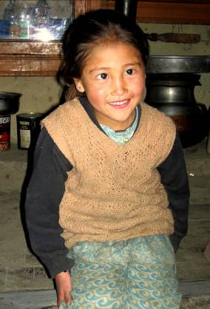
Name |  | RIGZEN CHOSKIT
Date of birth |  | 05/09/2005
Gender |  | Girl
Class in which to admit |  | UKG class
Currently present school |  | 2nd class government school
Favorite subject |  | English, Bhoti
Hobbies |  | Drawing, Dancing
Dream to become |  | Teacher
Few words about |  | Rigzen Choskit is very energic and cute girl, who has been dreaming about attending of SDPS since she had 4 years. She love to study and one day she would like to become a good teacher to pass knowledge and skills to children from her native area and make their life happier.
PARENTS |  | Choskit with her brother Choskit with her family
Father | Name | 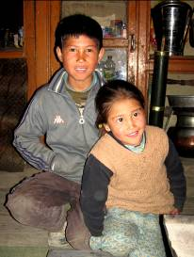  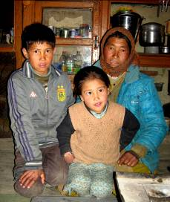  Tsewang Norboo
 | Job | No/Farmer
 | Education | 9th class
Mother | Name | Chewang Laskit
 | Job | No/Housewife
 | Education | No
HOUSEHOLD
Few words about |  | Choskit lives in an old house, which is 15km from SDPS. Hostel is required and needed, as it is impossible to walk to school and back home every day. Choskit has got three brothers, who are taking a good care of their youngest sister. Economic situation in the family is very poor, but is full of joy, love and good will.  Choskit’s parents wish so much to provide quality level of education at least for their talented daughter. Unfortunately, they have no funds for paying a private school. They will be infinitely grateful for finding a sponsor who can become a near friend of their family.
Number of adults |  | 2
Number of children |  | 4
Number of people in household in total |  | 6
Age and gender of children |  | 17 years (boy) | 13 years (boy) | 12 years (boy) | 5 years (girl)
Education of children |  | 10th class Gvt. | 9th class Gvt. | 3rd class Gvt. | 2nd class Gvt.

