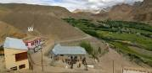  www.brontosauri |  |   SCHOLARSCHIP PROGRAM
 |  | Spring Dales Public School
 |  | Mulbekh; Ladakh, J&K, India
Date of issue |  | 23rd February , 2013
CHILD
Name |  | 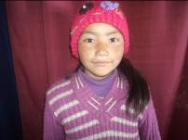  Jigmath Yangchan
Date of birth |  | 26/12/2005
Gender |  | Girl
Class in which to admit |  | 2nd class
Currently present school |  | SDPS
Favorite subject |  | Math, Hindi
Hobbies |  | Singing, Reading books
Dream to become |  | Teacher
Few words about |  | Jigmath Yangchan is one of the best students in 2nd class. With her lovely smile, she is always filling all tasks as a first one. She is very interested in learning and she loves environment in SDPS.
PARENTS |  | 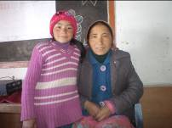
Father | Name | Rigzen Norbu
 | Job | Driver
 | Education | 5th class
Mother | Name | Padma Choton
 | Note | House wife/farmer
 | Education | Un-educated
HOUSEHOLD
Few words about |  | Yangchan lives in village pachikhar with her family. Unfortunately, the economic condition of the family is very poor. As Jigmath Yangchan is very talented, responsible and motivated student, their parents are trying very hard to safe money needed for paying of quality education for her.
Number of adults |  | 3
Number of children |  | 4
Number of people in household in total |  | 7
Age and gender of children |  | 19 years (boy) | 18 years (boy) | 11 years (boy) | 7 years (girl)
Education of children |  | 10th govt school | 5th class Gvt. | 5th govt class | 2nd SDPS

