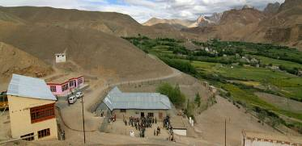 |  |   SCHOLARSCHIP PROGRAM
 |  | Spring Dales Public School
 |  | Mulbekh; Ladakh, J&K, India
Date of issue |  | 20th February, 2013
CHILD
Name |  | Jigmath Choswang
Date of birth |  | 14/01/2006
Gender |  | Boy
Class in which to admit |  | 3rd class
Currently present school |  | 3rd class SDPS
Favorite subject
Hobbies
Dream to become
Few words about |  | Jigmath Choswang is one of the best and most active students in 3rd class of SDPS. He is very fast in filling any tasks and always interested to get new ones. He is very good dancer and he loves theatre as well. He is very interested to be part of any dancing performance or play of SDPS.
PARENTS
Father | Name | Tashi Namgyal
 | Job | Driver/Farmer
 | Education | 4th class
Mother | Name | Deachen Choskit
 | Job | No/Housewife
 | Education | 5th class
HOUSEHOLD
Few words about |  | Jigmath Choswang lives in an old house with his big family. The economic situation is very poor, even though father tries to gain some money as driver during summer season. They try best to save money every year to provide good education for their kids.
Number of adults |  | 5
Number of children |  | 2
Number of people in household in total |  | 7
Age and gender of children |  | 13 years (boy) | 7 years (boy)
Education of children |  | 7th class SDPS | 3rd class SDPS

